**Module 3: Docker Part 1**

**Assignment – 3**

1. Created an image using the saved image in the previous assignment

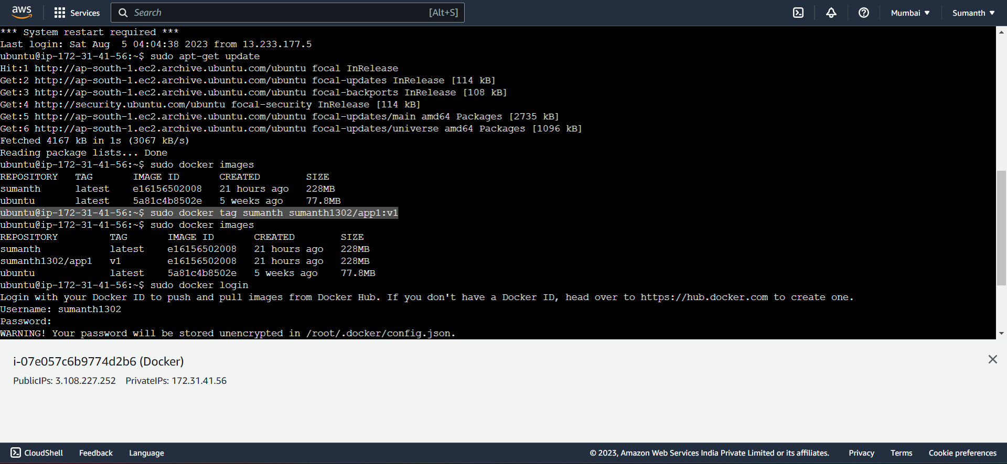

1. Uploaded this image on the docker hub

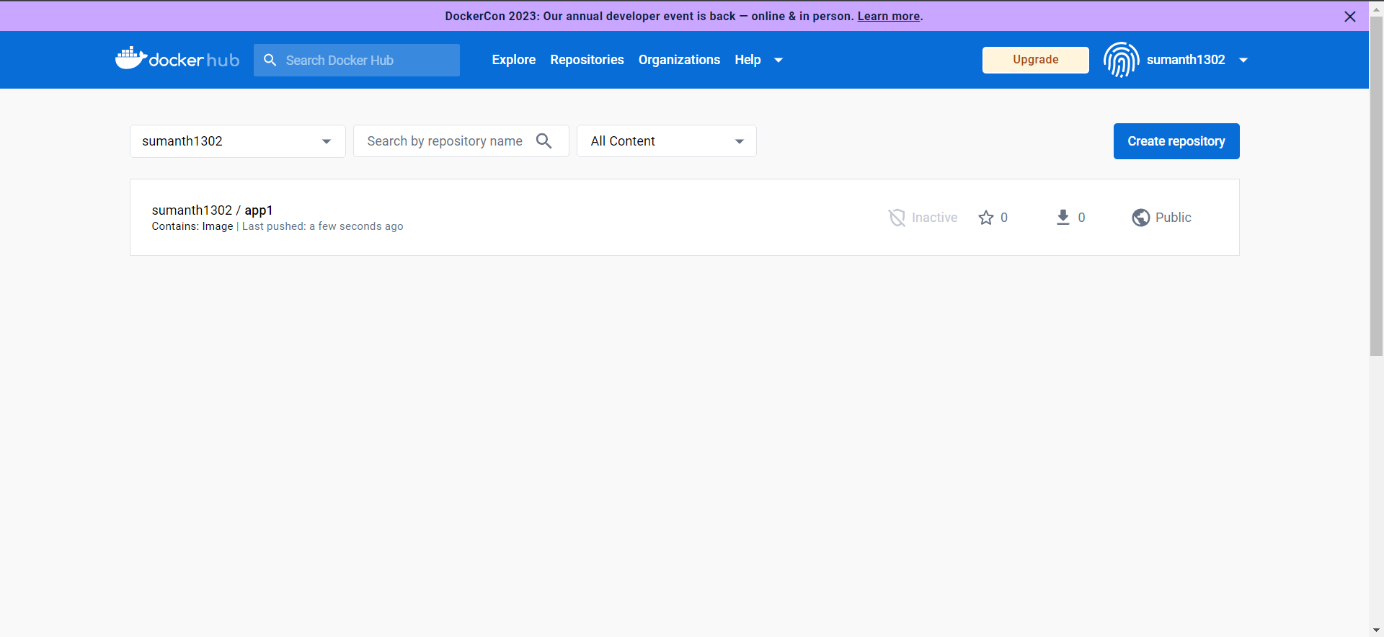

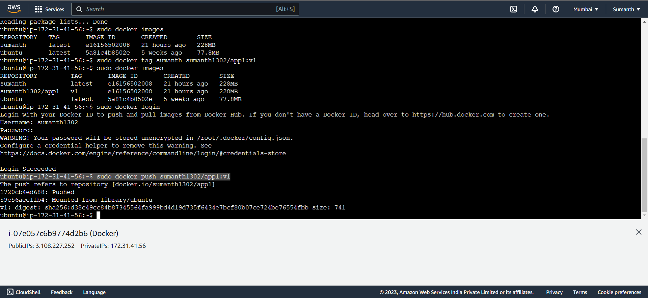

1. Created an EC2 instance and pulled this image from the docker hub

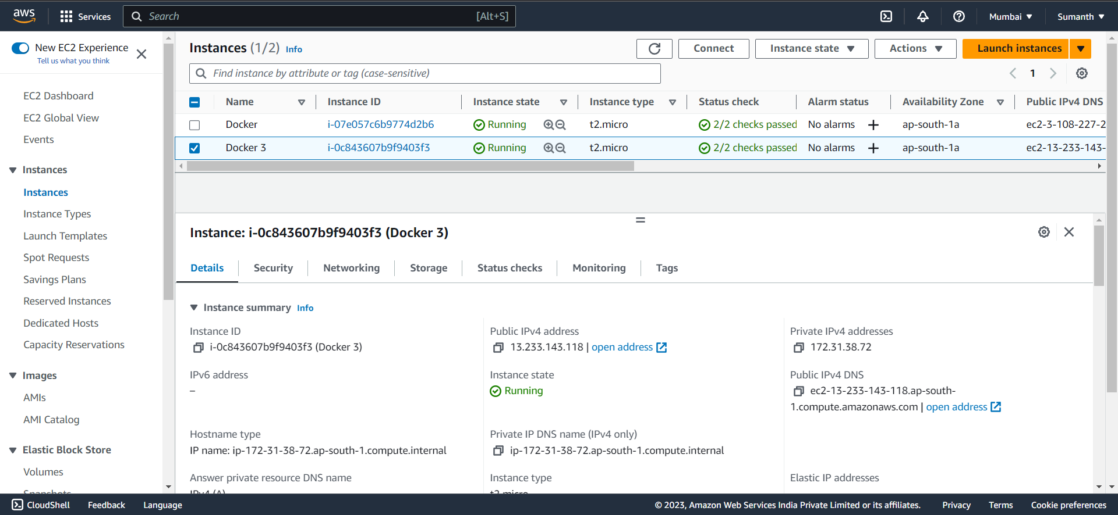

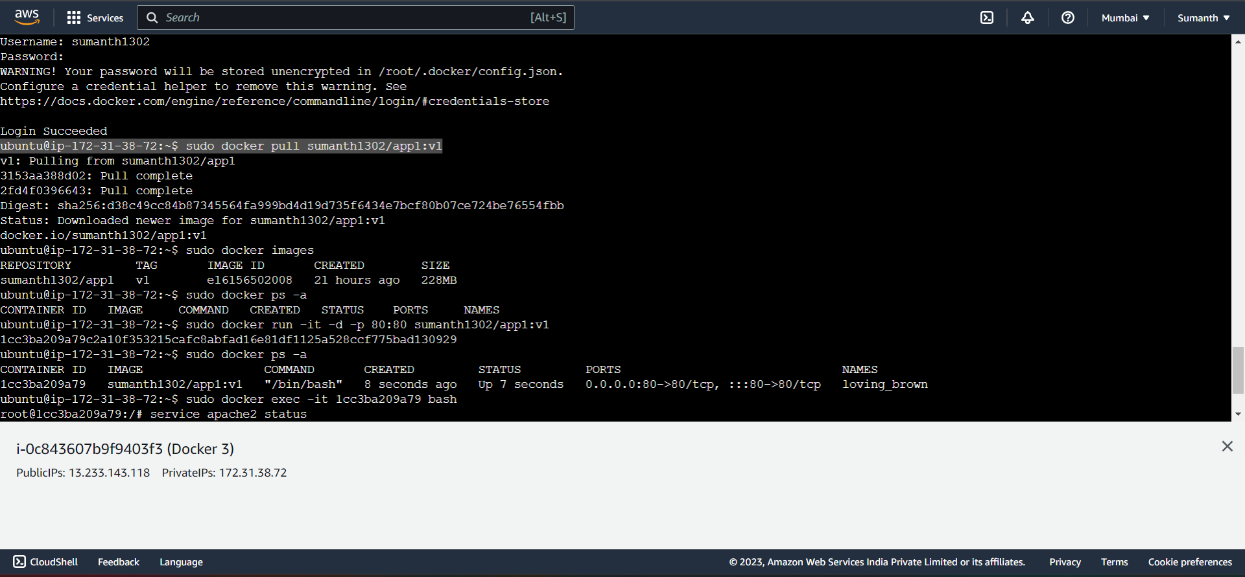

1. Started Apache2 service

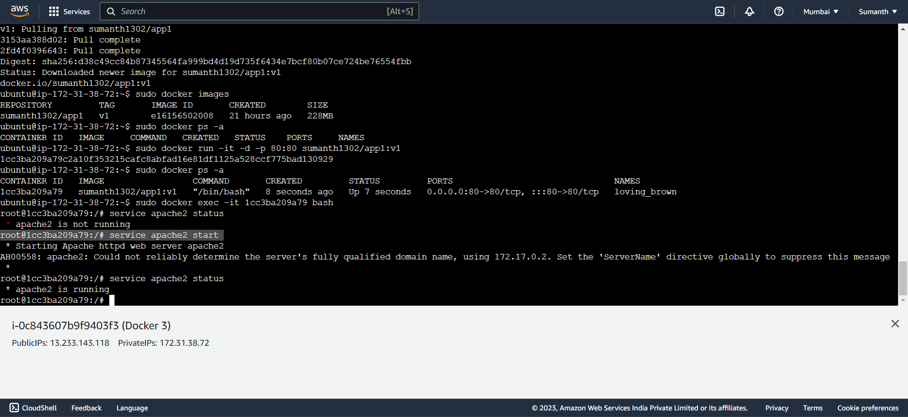

1. Able to see the Apache2 service

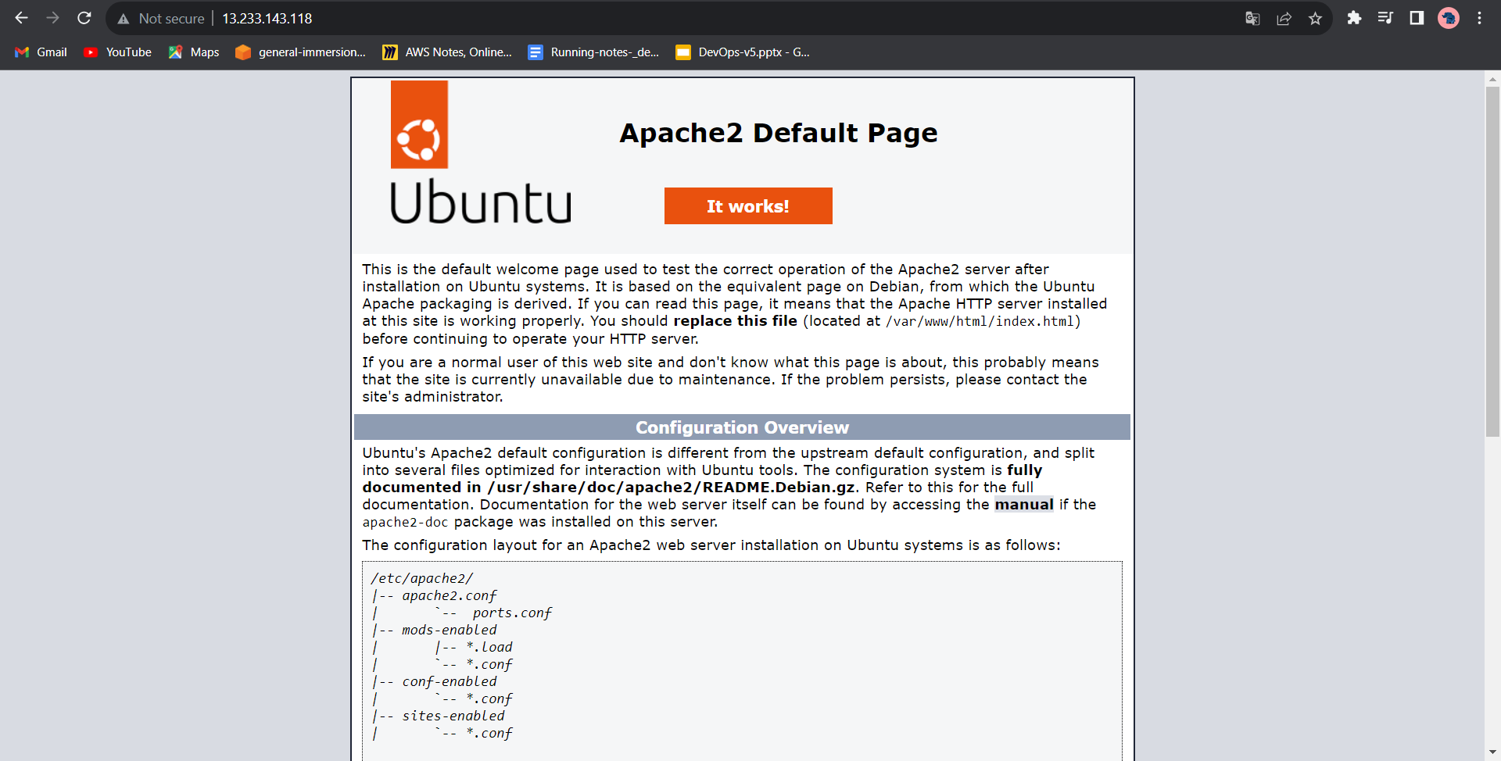

1. **Commands used for this assignment**

20 sudo docker tag sumanth sumanth1302/app1:v1

21 sudo docker images

22 sudo docker login

23 sudo docker push sumanth1302/app1:v1

sudo apt-get install docker.io -y

3 docker --version

4 clear

5 sudo docker login

6 sudo docker pull sumanth1302/app1:v1

7 sudo docker images

8 sudo docker run -it -d -p 80:80 sumanth1302/app1:v1

9 sudo docker ps -a

10 sudo docker exec -it 1cc3ba209a79 bash

service apache2 status

service apache2 start